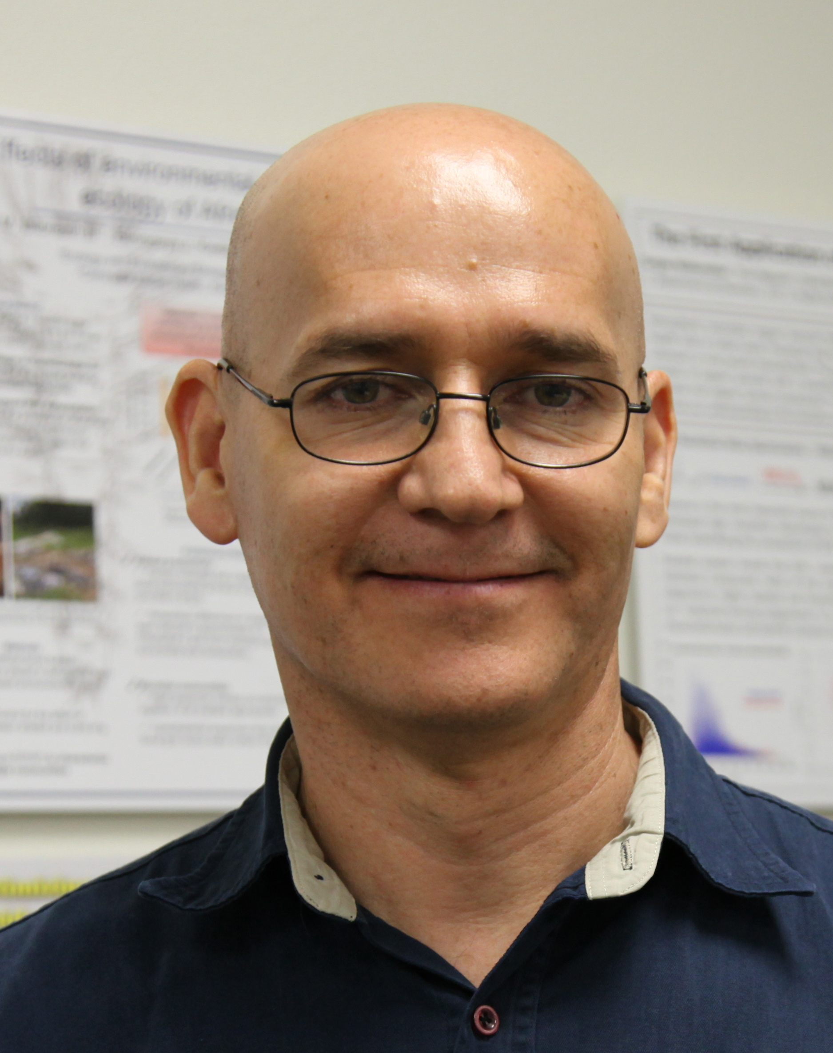 | Francisco Fernandez  School of Social Ecology  Department: Planning, Policy & Design  Adviser: Professor Victoria Beard  Concentration: Urban & Community Development  f.fernandez@uci.edu (949)331-6119
Leda Katebian
Henry Samueli School of Engineering
Department: Civil & Environmental Engineering
Adviser: Professor Sunny Jiang
Concentration: Environmental Engineering
lkatebia@uci.edu (949)374-6760
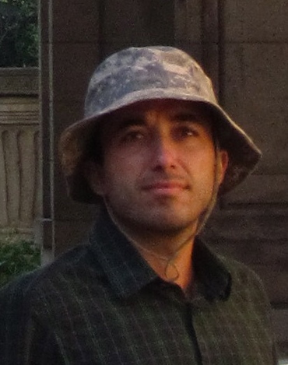 | Ali Mehran  Henry Samueli School of Engineering  Department: Civil & Environmental Engineering  Adviser: Professor Amir Aghakouchak  Concentration: Water Resources & Hydrology  aliakbam@uci.edu (949)929-4660
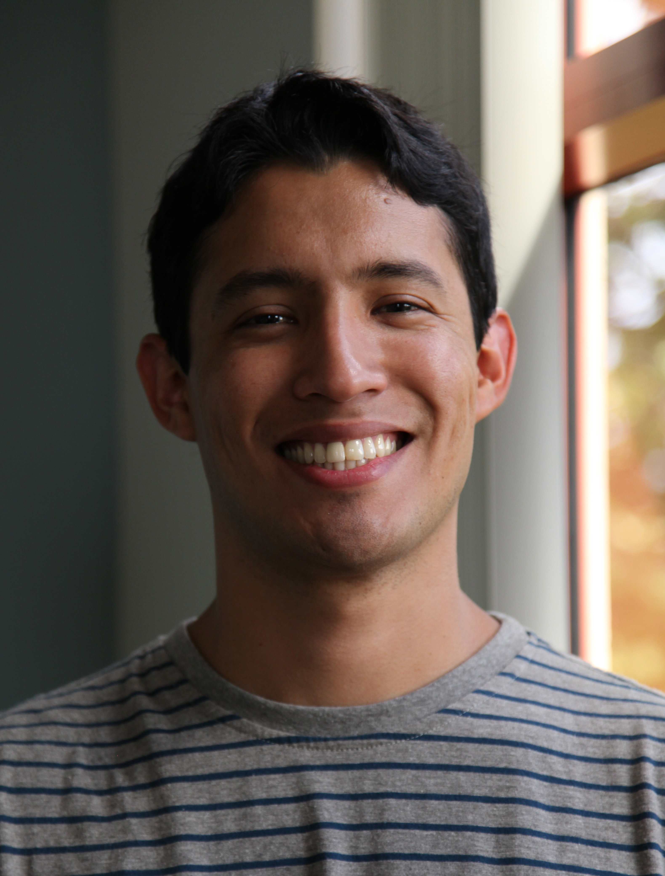 | Renzo Samame  School of Physical Sciences  Department: Chemistry  Adviser: Professor Scott Rychnovsky  Concentration: Synthetic/Organic Chemistry  rsamame@uci.edu (347)558-2692
Paul Stroik
School of Social Sciences
Department: Economics
Adviser: Professor Linda Cohen
Concentration: Environmental/Public Economics
pstroik@uci.edu (715)252-1703

